TESTING – Launching accuracy

Project: Design an Autonomous Robot

Task: To design an autonomous robot that is capable of navigating to a predetermined position while avoiding obstacles and firing objects at two targets. This is to be done in the shortest time possible.

Document Version Number: 2.0

Date: March 25th, 2015

Tester: Yu Chen Xu

Software Version: 1.0

Hardware Version: 3.1

Goal: The goal of this test is to improve the launcher’s ability to shoot over the wall and to increase its distance reached, while keeping its accuracy and its loading effectiveness.

Table of Contents

Purpose 3

Objectives 3

Procedure 3

Expected Results 3

Format of Output Required 4

Sample Calculations 4

Test Report 4

Conclusion 5

Action 5

Distribution 5

# Purpose

The purpose of the test is to see if the ball can reach further than 90cm, the result obtained in the last launching test, while being able to avoid the wall. In the previous launching test, the whole team has assumed that the ball does not have to travel above the wall. Therefore, this aspect needs to be fixed for the upcoming beta demo. The maximum distance reached is important as it will help to determine where the robot shooting position will be at in the competition. In the beta demo, the target will be at 85cm in the north east direction of the top right edge. The robot’s previous reaching distance, 90cm, is not valid anymore as it is not a good option to shoot near the wall. It is safer to shoot in a wide zone, where the robot can rotate freely.

This test will be done with the hardware version 3.0 and a testing code that can be found in the “Launching test” folder.

# Objectives

The objective of the test is to increase the maximum distance reached by the ball. Those information are essential to find out the optimal shooting spot on the enclosure, in the beta demo.

This test is a simulation of the shooting part of the competition. Since the competition will be held at an indoor place, there will not be any factors that affect the launching of ball. Therefore, it is correct to assume that doing the test in the lab room can represent well the real situation.

# Procedure

1. Place the robot at a position (0, 0) (i.e.: at an intersection of the grids).
2. Place a 20cm high wall at 30cm in front of the robot.
3. Launch a Ping-Pong ball along with the loading mechanism.
4. Measure the X and Y components.
5. Repeat step 3) and 4) 10 times.

# Expected Results

The expected result is that the ball will land near (0, 120), after flying above the wall. In the beta demo, as the target will be at 85cm in the north east direction of the top right edge, shooting at the limits of the enclosure wouldn’t be a best option, because the robot might hit the wall when it turns. So, having a 120cm projection will leave the robot more freedom.

The best case of the test is that the ball will land near (0, 120) with a 7.5 cm radius error in 100% of the cases. This will prove the accuracy and the exactness of the launcher. The worst case scenario of the test would be that the landing spot is more than 7.5cm far from the desired point (0, 120) in 100% of the trials.

As for the loading system, it is expected that it can load balls without human intervention.

# Format of Output Required

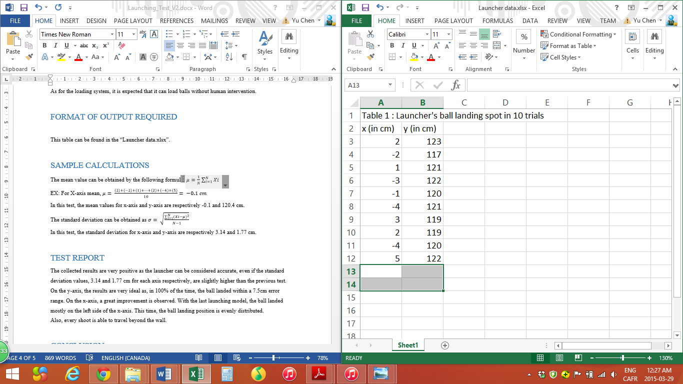

This table can be found in the “Launcher data.xlsx”.

# Sample Calculations

The mean value can be obtained by the following formula: $μ=\frac{1}{N}\sum_{i=1}^{N}{Xi}$

EX: For X-axis mean, $μ= \frac{\left(2\right)+\left(-2\right)+\left(1\right)+…+\left(2\right)+\left(-4\right)+(5)}{10}= -0.1 cm$

In this test, the mean values for x-axis and y-axis are respectively -0.1 and 120.4 cm.

The standard deviation can be obtained as $σ= \sqrt{\frac{\sum_{i=1}^{N}{({Xi-μ)}^{2}}}{N-1}}$

In this test, the standard deviation for x-axis and y-axis are respectively 3.14 and 1.77 cm.

# Test Report

The collected results are very positive as the launcher can be considered accurate, even if the standard deviation values, 3.14 and 1.77 cm for each axis respectively, are slightly higher than the previous test.

On the y-axis, the results are very ideal as, in 100% of the time, the ball landed within a 7.5cm error range. On the x-axis, a great improvement is observed. With the last launching model, the ball landed mostly on the left side of the x-axis. This time, the ball landing position is evenly distributed.

Also, every shoot is able to travel beyond the wall.

# Conclusion

This testing can be considered “passed” as the observed output is closed to the expected results. Some problems have been fixed. First, the ball can travel beyond the wall, a task that the launcher V.1 can’t do. Second, the distance travelled is increased by 30cm, which means that the robot doesn’t have to be placed near the wall in the beta demo.

On each axis, the ball always landed within a 7.5 cm radius. Last, the loading system still works well.

# Action

This test report should be keep within the mechanical team in order to bring adjustments to the launcher in the future.

# Distribution

This testing belongs to the mechanical development.